PATERNITY POLICY AND PROCEDURE

Person(s) responsible for updating the policy: | Jenna Gipson
Dates consulted on with recognised unions: | From: 17/07/2023 To: 18/08/2023
Date approved by Trustees: | 29/08/2023
Date of next review: | September 2026

Mission, Vision and Values

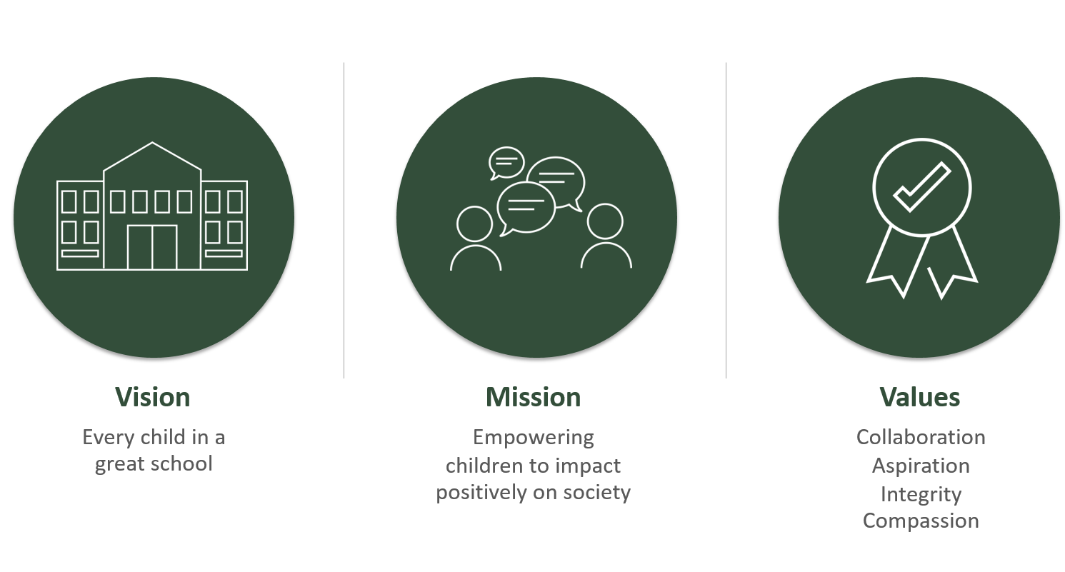

WeST Core Values
WeST holds four core values which underpin the engagement, motivation and retention of employees, no matter what their role in the organisation.

- Collaboration
Creating a shared vision and working effectively across boundaries in an equitable and inclusive way to skilfully influence and engage others. Building and securing value from relationships, developing self and others to achieve positive outcomes.
- Aspiration
Having high expectations, modelling the delivery of high quality outcomes. Showing passion, persistence and resilience in seeking creative solutions to strive for continuous improvement and excellence.
- Integrity
Acting always with the interests of children and young people at our heart, and with a consistent and uncompromising adherence to strong moral and ethical principles. Communicating with transparency and respect, creating a working environment based on trust and honesty.
- Compassion
Recognising need in others and acting with positive intention to promote well-being and improve outcomes.

Providing Accessible Formats
If you are unable to use this document and require it in a different format please contact Human Resources.

WeST Policy Suite
All Trust HR Policies are accessible via the WeST Staff Portal. Please contact your local administrative office or Human Resources for log-in details.

HR Helpline: 01752 891754 ext. 1765
HR Email: HR@westst.org.uk

Contents

Mission Statement 1
Contents 3
1. Policy Introduction, Purpose and Principles 4
2. Notification 4
3. Commencement of Leave 5
4. Timescales 5
5. Paternity leave and pay eligibility and entitlement 5
6. Return to work (Guidance) 6
7. Pay increases and pension contributions and leave 6
8. Time off for Ante Natal Care 6
Terms and Abbreviations 7
APPENDIX 1 – PATERNITY LEAVE AND PAY - ELIGIBILITY AND ENTITLEMENTS 9
APPENDIX 2 - APPENDIX 2 - REQUEST FOR TIME OFF FOR AN APPOINTMENT 10
POLICY HISTORY 11

Introduction, Purpose and Principles
This policy applies to all employees within the Trust, regardless of terms and conditions of employment (e.g. both Teacher and Support Staff). It does not apply to agency workers, contractors or volunteers.

WeST is committed to equality in its Paternity Policy and Procedure. The conditions for qualification for leave and pay under this policy will not disadvantage any employee on the grounds of age, race or ethnicity, disability, gender and marital status, gender identity or sexual orientation.

The intention is that this policy does not erode contractual terms protected under TUPE.

The Paternity Policy and Procedure is to be taken in accordance with national, local and statutory conditions of service. The Trust’s Paternity Policy and Procedure shall apply to all employees regardless of the number of hours worked per week. Nothing in the provisions shall be construed as providing rights less favourable than statutory rights.

The policy is provided to allow eligible employees paid leave:
- to care for a child
- to support the parent who has given birth to a child
- to support the main adoptive parent who is taking the primary caring responsibility
- to support for the legal or intended parent of the child who is taking the primary caring responsibility (in the case of surrogacy, where one parent is biologically related to the child)

There are two elements to the scheme, the statutory entitlements and the contractual entitlements. This policy is an amalgamation of the two sets of entitlements.

PROCEDURE

Notification

Information to provide before the end of the 'qualifying week'

Eligible employees intending to take leave must advise their manager of the expected due date at least 15 weeks before the baby is expected. They must then give notice in writing to their line manager, telling them:

- They are having a baby and intend to take Paternity leave
- the expected week the baby is due or the expected date of placement in the case of adoption
- the relationship of the employee to the parent who has given birth, or, in the case of surrogacy, the main legal or intended parent of a child, or, in the case of adoption, the main adopter.
- that they will use the leave to care for either the child or the birth parent

This can be done by filling in the online form (previously called form SC3), which is available on the Government website: https://www.tax.service.gov.uk/fill-online/apply-for-statutory-paternity-pay.

The completed the form can be download or printed. This must then be forwarded to the HR Admin or the School Administrator, they will inform payroll and send out a Paternity Information letter which includes notification forms which must be completed and returned.

Information to provide at least 28 days before starting leave
Employees must notify their line manager in writing when they want their leave to start, and how much leave they want to take, at least 28 days beforehand, or in the case of an adoption within seven days of notification of matching with a child, unless this is not reasonably practicable. They need to confirm:

- whether they wish to take one or two weeks leave
- if taking two weeks leave, whether these are consecutive weeks, or to be taken in separate one-week blocks
- the date when leave is to begin (on both occasions if separating into two periods and the later date is currently known; otherwise, separate notification must be given 28 days before the second week block).

The employee can change the date on which the leave will start by giving 28 days’ notice of the change of date, or as soon as is reasonably practicable in the case of a premature or delayed birth.

Commencement of Leave
When the employee begins paternity leave the line manager must ensure that the relevant absence form is completed and the Trust’s HR Department or the School Administrator is informed, stating the date that the employee commenced leave. The reason for absence should be indicated in the ‘other’ category and ‘maternity support leave’ or ‘adoption support leave’ should be clearly written in the box.

Timescales
Upon return to work the line manager must ensure that they notify the HR Department or School Administrator stating the date that the employee returned to work following paternity leave (formerly known as maternity or adoption support leave).

GUIDANCE

Paternity leave and pay eligibility and entitlement.
An employee with less than 26 weeks continuous service at the 15th week before the child is due or the week in which the adoptive parent is notified of having been matched with the adoptive child and is:
- a secondary birth parent; or
- the spouse or partner of the parent who has given birth (or main adopter); or
- the child’s adopter; or
- the intended parent, or legal parent (if you’re having a baby through a surrogacy arrangement).

is entitled to take one week’s leave with pay following the birth or placement (see appendix 1).

An employee with 26 weeks or more continuous service at the 15th week before the child is due and is:
- the nominated carer of an expectant person

is entitled to take one week’s leave with pay following the birth (see appendix 1)

An employee with 26 weeks or more continuous service at the 15th week before the baby is due or the week in which the adoptive parent is notified of having been matched with the adoptive child and is:
- the secondary birth parent OR
- the spouse or partner of the parent who has given birth (or adopter) OR
- the child’s adoptive parent who is not taking the main caring responsibility OR
- the second intended parent, or legal parent (if you’re having a baby through a surrogacy arrangement).

is entitled to take either one- or two-week’s leave, in consecutive weeks, or separate one-week blocks following the birth or placement of the child (see appendix 1).

There is no entitlement to take odd days. This is because this option includes the statutory entitlements of leave and pay and a condition for the receipt of statutory pay is that the leave is taken in a block or blocks. Pay during the first week of leave will be full pay. Any entitlement to statutory pay will be included in this amount and the Trust will be able to offset this against the full pay. Pay during the second week of leave will be any Statutory Paternity Pay due. (An employee is eligible for Statutory Paternity Pay if their average weekly earnings are at or above the Lower Earnings Limit for National Insurance at the end of the qualifying week). (See appendix 1). Current rates are available from the Gov.UK website.

Any leave must finish within 52 weeks of the birth or placement of the child (or due date, if the baby is early).Leave can start on any day of the week on or after the child’s birth/date of placement. If the baby is born earlier than the fourteenth week before it is due and but for the birth occurring early the employee would have been employed continuously for 26 weeks then the employee will have been deemed to have the necessary length of service.

Employees wishing to take their paternity leave (i.e. in odd days) must obtain the approval of their manager. The statutory scheme which is applicable to employees with 26 weeks or more continuous service allows for leave to be taken only in one-week blocks and up to two weeks. Therefore, employees who wish to take leave flexibly will only be entitled to the contractual element of the scheme which is one week.

Only one or two periods of leave and pay, which cannot exceed two weeks, can be taken by one employee in respect of each birth or adoption irrespective of whether more than one child is born or adopted.

Employment rights are protected while the employee is on paternity leave. This includes the right to:
- Pay rises
- Build up (accrue) holiday
- Return to work

A qualifying employee will be entitled to paid leave if the child is stillborn after 24 weeks of pregnancy or born alive at any point during the pregnancy.

Return to work
Employees are entitled to return to work to the same job following paternity leave.

Pay increases and pension contributions and leave
Teachers - During the period of paid paternity leave, pension contributions will be paid and deducted from the teacher’s pay in the usual manner. The service will count as normal for pension purposes i.e. as if the employee had been at work.

All other staff - During the period of paid paternity leave, employees who are members of the Local Government Pension Scheme, will pay basic pension contributions on the pay actually received but the Trust will pay pension contributions on the pay the employee would have received had they been at work (notional pay). The pension will accrue as normal as if the employee had been at work.

Time off for Ante Natal Care
All employees (from day one of their employment) and agency workers (after 12 weeks in the same role) have the right to take time off to accompany a pregnant person with whom they are having a child at up to two antenatal appointments. This time off will be unpaid.

The following employees have the right to take time off to accompany a pregnant person with whom they are having a child at up to two antenatal appointments:

- the baby’s secondary birth parent
- the spouse or partner of the parent who has given birth (or main adopter)
- in a long-term relationship with the parent who has given birth
- the intended parent, or legal parent (if you’re having a baby through a surrogacy arrangement). If you're in a couple, only one person has the right to time off to accompany the surrogate to the antenatal appointments.

In the circumstance of adoption, the main adopter's partner (second adopter) is entitled to take unpaid time off for up to 2 appointments.

This time off will be unpaid and it is expected that normally no more than half a day is needed for an antenatal appointment, however the right to time off includes time to travel to the appointment and any waiting time needed at the appointment. The maximum amount of time that can be taken is six-and-a-half hours on up to two occasions.

In all circumstances, should additional appointments arise the individual should liaise with their Principal/Headteacher/Director TLI and any additional unpaid time off will be at their discretion.

In order to request this time off, please complete the ante-natal care form (see Appendix 2).

Please see the Trust’s Maternity Policy for information on Antenatal Appointments for pregnant employees.

Terms and Abbreviations

Person who has given birth / Pregnant parent | The person who is due to, or has given birth to the child
Secondary birth parent | Not the person who has given birth to the child, but is a biological birth parent
Partner | Someone who lives with the parent/main adopter and the child in an enduring family relationship, but is not related to the them by way of their; parent, grandparent, sibling, cousin, or a sibling of their parents. A partner includes civil and married partners.
Legal Parent | Someone who has obtained legal responsibility for a child following surrogacy, through a parental order, or has the legal status due to being biologically related to the child, in cases where the surrogate status is single. Whether the surrogacy agreement is for an individual or a couple, there must be a biological link to the child from at least one party.
Intended Parent(s) | These are couples or individuals who are having a child through a surrogacy arrangement. At least one of the intended parents (if in a couple) must be genetically related to the child. No legal parental order has yet been granted.
Matched | A person is matched with a child for adoption when an adoption agency decides that the person would be a suitable adoptive parent for the child, either individually or with another person.
Paternity Leave  (formerly known as Maternity and Adoption Support Leave) | A maximum of 2 weeks’ leave (subject to eligibility) which can be used to care for a child or support the child’s birth parent/adopter.
Nominated carer | The person nominated by the parent who has given birth to provide support following the birth.
Placement | The placement of a child for adoption occurs when the child goes to live with the adopter permanently with a view to being formally adopted.
Statutory Paternity Pay  (SPP) | A weekly state benefit for employees who are on Paternity Leave (subject to eligibility). Current rates are available from the Gov.UK website.

APPENDIX 1 - PATERNITY LEAVE AND PAY - ELIGIBILITY AND ENTITLEMENTS

Employee with less than 26 weeks continuous service at the 15th week before the baby is due or at the week in which the adoptive parent is matched with a child
Employee with more than 26 weeks continuous service at the 15th week before the baby is due or at the week in which the adoptive parent is matched with the child

Who is:
the secondary birth parent, OR the partner or nominated carer of the pregnant parent
OR the child’s adoptive parent OR the child’s intended parent/legal parent
Who is:
the secondary birth parent, OR the partner or nominated carer of the pregnant parent
OR the child’s adoptive parent OR the child’s intended parent/legal parent

Who is:
the nominated carer

Either one or two week’s leave (no odd days) to be taken any time in the 52 weeks after the birth (or due date if later) or adoption of their child.

Week 1 – full pay including any statutory pay

Week 2 – SPP or 90% of average weekly earnings if less than SPP

One full week’s leave with pay following the birth to be taken any time in the 52 weeks after the birth (or due date if later) or adoption of their child.

One full week’s leave with pay following the birth or placement to be taken any time in the 52 weeks after the birth (or due date if later) or adoption of their child.

SPP = Statutory Paternity Pay

Current rates are available from the Gov.UK website.

APPENDIX 2 – REQUEST FOR TIME OFF FOR AN APPOINTMENT

Part 1 - To be completed by employee
Employee Name
Date of appointment
Time of appointment
I have the following relationship with the pregnant person I am accompanying to an appointment or her expected child (please tick as appropriate).
I am the spouse or civil partner of the pregnant parent
I live with the pregnant parent in an enduring family relationship, although I am not their parent, grandparent, sister, brother, cousin, or sibling to their parents.
I am the secondary birth parent of the expected child
I am the intended parent/legal parent of the expected child (if through surrogacy)
I declare the following to be true (please tick each box)
My purpose in taking time off is to accompany the above pregnant at an antenatal appointment.
The antenatal appointment has been made on the advice of a registered medical practitioner, midwife or nurse.

The appointment relates to my potential adoption process.
Signed
(employee)
Date

Part 2 - To be completed by line manager
Please tick
Time requested has been accepted
Time requested has been declined
Please state reason for declining:

Signed
(manager)
Date

Notes for line manager:
- This time off is unpaid. Please ensure that you record the absence using the necessary documentation/on-line absence form.
- Save a copy of the form in the employees’ HR file
- A maximum of 2 appointments can be requested (maximum of 6.5 hours per day)

POLICY HISTORY
Policy Date | Summary of change | Contact | Version/ Implementation Date | Review Date
August 2016 | Revised policy for academy schools based on LA policy previously consulted upon with trade unions. | HR ONE | September 2016
May 2017 | Updated policy with new Trust name | WeST HR | May 2017
September 2017 | Publication date | WeST HR | September 2017 | Annually
July 2019 | Full policy review and consultation.  JCNC and staff consultation.  Trust Board agreement 11 July 2019. | WeST HR | July 2019 | Biannually or at change in Statutory guidance.
June 2023 | Update to adopt gender neutral terminology and include further guidance of arrangements following surrogacy | WeST HR | September 2023 | September 2025
April 2024 | Update to adopt changes in legislation, in-line with “The Paternity Leave Amendment Regulations 2024” | WeST HR | TBC | September 2026

